TURKLANG - 2024

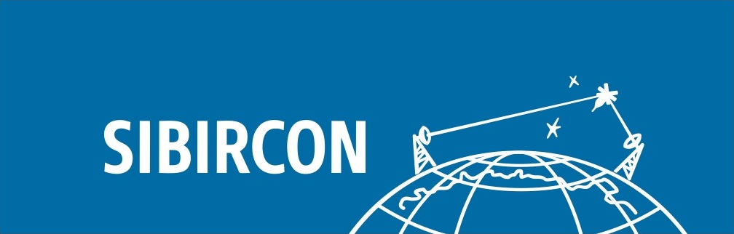 | 

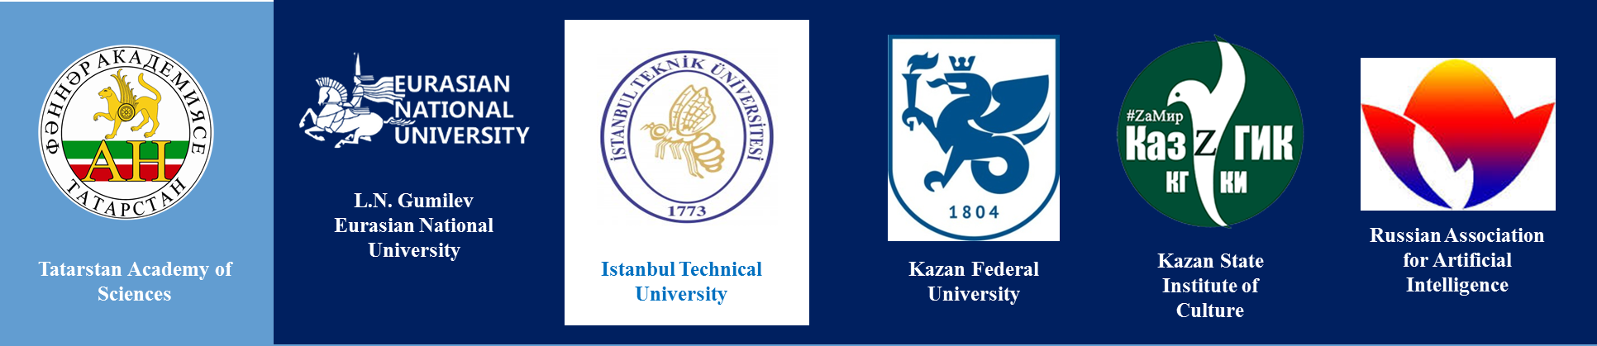

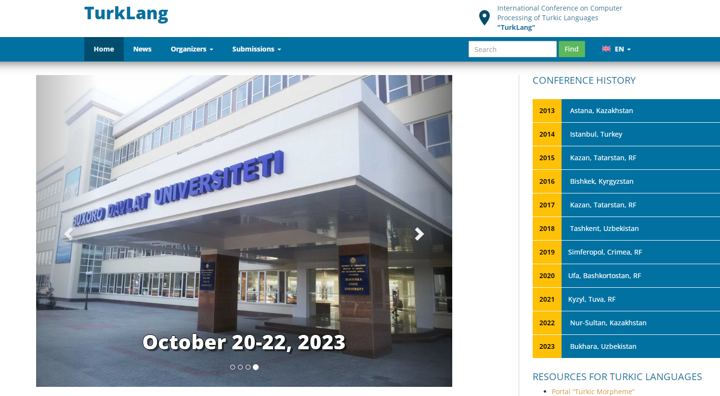

Dear Colleagues!

We are glad to inform you that the XII International Conference on Computer Processing of Turkic Languages “TurkLang 2024” will be held within two large events: International Forum “Kazan Digital Week” (KDW) (kazandigitalweek.com/) and International multiconference on engineering, computer and information sciences “SIBIRCON” (sibircon.ieeesiberia.org/).

This conference is dedicated to the Year of Scientific and Technological Development in the Republic of Tatarstan and the 15th anniversary of the Institute of Applied Semiotics of the Academy of Sciences of the Republic of Tatarstan (antat.ru/ru/ips/).

International Conference TurkLang 2024 will be held on September 9–11, 2024 at the Kazan Expo International Exhibition Center (kazanexpo.ru).
The conference will be held both in personal and virtual forms.

Directions of Conference Work:
- Formal models and software services for turkic languages
- National localization of computer systems and terminology
- Electronic corpus of the turkic languages
- Systems for morphological and syntactic text processing
- Semantic word processing technologies
- Machine translation systems and technologies
- Speech technologies
- Intelligence systems and technologies for learning turkic and foreign languages
- Linguistic ontologies and knowledge graphs for turkic languages
- Turkic languages as the basis for the creation of new intelligence technologies and knowledge processing systems
The conference agenda includes plenary and sectional sessions, round tables, exhibition of software developments (as part of the general exhibition of the KDW in Kazan Expo).
The detailed information is available on the conference website: turklang.ieees.org
Conference working languages
Conference working languages are English, Russian, Tatar.
Presentations are to be presented in English.

Important Dates:
Submission of full paper texts: until July 1, 2024.
Distribution of review results: August 10, 2024.
Publication of the conference program: August 26, 2024.
Conference dates: September 9-11, 2024.

Paper Submission Procedure
Full paper texts will be accepted until July 22, 2024.
Papers are to be uploaded on the conference website: turklang.ieees.org

A conference symposium will be organized as part of the conference. All papers will undergo a three-level selection process.

The first level is a symposium.
Full-text papers accepted and presented at the conference in English will be sent for inclusion in the IEEE Xplore digital library, provided that the articles meet the IEEE Xplore volume and quality requirements.
The second level.
The TurkLang section of the journal “Philology and Culture”, published by Kazan Federal University, will be formed out of individual papers, which cover the topics of philological field.
The third level.
The papers, not included in the symposium, but prepared at a good level and being of interest to conference participants, will be recommended for the main part of the conference and will be indexed in the RSCI.
Organizers

Academy of Sciences of the Republic of Tatarstan
Institute of Applied Semiotics

L.N. Gumilev Eurasian National University
Ministry of Science and Higher Education of the Republic of Kazakhstan
Institute of Artificial Intelligence

Istanbul Technical University

IEEE Russia Siberian Section

Kazan Federal University
Institute of Philology and Intercultural Communication

Kazan State Institute of Culture

Russian Association for Artificial Intelligence

Programme Committee:
- Adaly Eshref (Istanbul, Turkey) - Co-chairman
- Minnikhanov Rifkat (Kazan, Tatarstan, Russia) – Co-chairman
- Suleymanov Dzhavdet (Kazan, Tatarstan, Russia) – Co-chairman
- Sharipbayev Altynbek (Astana, Kazakhstan) – Co-chairman
- Abdurakhmonova Nilufar (Tashkent, Uzbekistan)
- Altenbek Gulila (Urumchi, China)
- Arzamasov Alexey Andreevich (Kazan, Tatarstan, Russia)
- Aripov Mirsaid (Tashkent, Uzbekistan)
- Bekmanova Gulmira (Astana, Kazakhstan)
- Gatiatullin Ayrat (Kazan, Tatarstan, Russia)
- Gilmullin Rinat (Kazan, Tatarstan, Russia)
- Dybo Anna (Moscow, Russia)
- Ergesh Banu (Astana, Kazakhstan)
- Zamaletdinov Radif (Kazan, Tatarstan, Russia)
- Israilova Nella (Bishkek, Kyrgyzstan)
- Kubedinova Lenara (Simferopol, Crimea, Russia)
- Mamedova Masuma (Baku, Azerbaijan)
- Oorzhak Baylak (Kyzyl, Tuva, Russia)
- Oflazer Kemal (Doha, Qatar)
- Rakhimova Diana (Almaty, Kazakhstan)
- Salchak Aelita (Kyzyl, Tuva, Russia)
- Sirazitdinov Zinnur (Ufa, Bashkortostan, Russia)
- Soloviev Valery (Kazan, Tatarstan, Russia)
- Sulaimanov Muhammad Ali (Simferopol, Crimea, Russia)
- Tatevosov Sergei (Moscow, Russia)
- Toirova Guli (Bukhara, Uzbekistan)
- Torotoev Gavril (Yakutsk, Saha, Russia)
- Tukeev Ualisher (Almaty, Kazakhstan)
- Fridman Alexander (Apatity, Murmansk region, Russia)
- Hamroyeva Shahlo (Tashkent, Uzbekistan)
- Chumakaev Aleksey (Gorno-Altaysk, Altay, Russia)
Organizing Committee
Chairman of the organizing Committee:
Minnikhanov Rifkat (Kazan, Tatarstan, Russia)

Deputies Chairman:
Timerhanov Aynur (Kazan, Tatarstan, Russia)
Gilmullin Rinat (Kazan, Tatarstan, Russia)

Members of the organizing committee:
Gatiatullin Airat (Kazan, Tatarstan, Russia) - Head of the Coordinating Council of the International Conference TurkLang
Ahmadieva Roza (Kazan, Tatarstan, Russia)
Zamaletdinov Radif (Kazan, Tatarstan, Russia)
Kazankin Grigoriy (Novosibirsk, Russia) – spokesman of IEEE Siberian Section
Khairullin Airat (Kazan, Tatarstan, Russia)
Khasyanov Airat (Kazan, Tatarstan, Russia)
Gabdrakhmanova Aigul (Kazan, Tatarstan, Russia)

Conference Milestones:
“TurkLang 2013” - Astana, Kazakhstan, 3.10.13-4.10.13
“TurkLang 2014” - Istanbul, Turkey, 6.11.14-7.11.14
“TurkLang 2015” - Kazan, Tatarstan, RF, 17.09.15-19.09.15
“TurkLang 2016” - Bishkek, Kyrgyzstan, 24.08.16-26.08.16
“TurkLang 2017” - Kazan, Tatarstan, RF, 18.10.17-21.10.17
“TurkLang 2018” – Tashkent, Uzbekistan, 18.10.18-21.10.18
“TurkLang 2019” – Simferopol, Crimea, Russia, 3.10.19-5.10.19
“TurkLang 2020” – Ufa, Bashkortostan, Russia, 18.10.20-20.10.20
“TurkLang 2021” – Kyzyl, Tuva, Russia, 21.09.21 -23.09.21
“TurkLang 2022” – Nur-Sultan, Kazakhstan, 16.06.22 – 18.06.22
“TurkLang 2023” – Bukhara, Uzbekistan, 20.10.23 – 22.10.23

Contact:
Gatiatullin Airat Rafizovich E-mail: ayrat.gatiatullin@gmail.com

Location: Kazan Expo International Exhibition Center (kazanexpo.ru)



